CV

Contact
Brunold M. Loidl  Tel +49-172-2619047  +43-680-2170231  +43-720-975215  +49-208-385309  Fax +43-1-25330338357  Email: brunold.loidl@software-project.de  P.O.Box 10 12 15  D-45412 Mülheim an der Ruhr  Alleestrasse 9a  A-3400 Klosterneuburg | 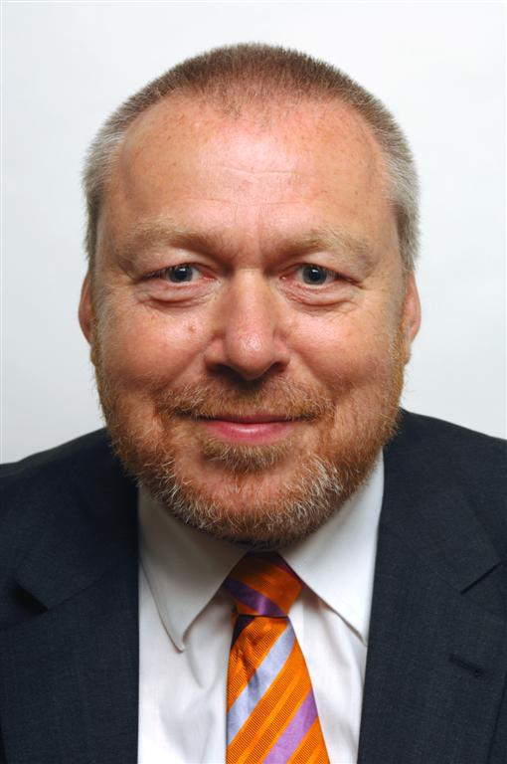

Birthplace Klosterneuburg / Austria / Europe

Family status married

Nationality Austrian (German permanent resident Visa, Japanese
Possible), Chinese permanent multiple Business Visa

Military service 1973 8 month in Austria

Education 1960 - 1964 Primary school Klosterneuburg
1964 - 1968 Grammar school Klosterneuburg
1968 - 1973 (HTL) TGM College for Communications and electronics
1978 - 1982 Computer science at Technical University Vienna
2012 Licensed Exportconsultant for Asia
Working since 1973

Driving license for cars and motorbikes (Austrian and German license)
International driving license

Languages English (fluent), German (native), Japanese, Chinese, Vietnamese, Tagalong, Spanish (basic)

Actual position Social Media and Marketing for Green Tourism and Contemporary Art in China, Support of Companies Relations to China
Position before Technology for Chinese Highway in Zhejiang, Shaanxi and Hubei – Telematic Support

Focus of Business Coaching of projects in virtual teams
Executive program management in large international projects
Crisis-management and risk-management
Reduction of project targets to the possible size and no
over delivery
Generation of success for the customer and the Project members
Infrastructure optimization, mergers and acquisitions

Job history:

2008 - now china-consult Consulting Chinese Relations

Support Trade, Technology and Production Support with China, Marketing for Green Tourism and Contemporary Art, Business Development in China and South Korea,. Certified Export consultant. Setup China Office for SAP – Consulting Companies.
2011-2012 wwicon Business Development

Business Development for Consulting and IT on the Chinese Market
2009 - 2011 sopro Consulting Telematics

Chinese Highways in Zhejiang, Shaanxi and Hubei
Technology Transfer, Traffic Control consulting
2008 - 2009 Siemens Carveout Manager Program Director

Volume 3,5 mio Euro budget

Outcarving of the SEN and ISEC department out of Siemens. About 2000 employees with infrastructure in 11 countries. Including infrastructure, SAP, NONSAP, HR

Process and Infrastructure separation.
2008 – 2008 SIS D Proposal Management and PM-Candidate
Application Development Project 7 mio Euro German Post
2008 – 2008 SIS D Project Consulting / Reviewing

For German Banks in Frankfurt / Main in ATM – Service and Backoffice – Project – Process Optimazion
2007 – 2008 SIS GO Transformation Manager

Transformation Manager Project “Transformation Operational Framework” budget 800 Million Euro per year. Rollout of global services processes at Siemens Infrastructure Management and cost saving about 30 % for Siemens Global Operations. Setup Global Production Centers (GPC). Products OSD, OCD, OSD, AIP
2006 – 2007 Siemens PSE Project Management / Controlling

For new Software Projectmanagement Toolbox SEM NG Using Visual Studio, Eclipse, Project Wizard, Infopath for Siemens PSE Department (7000 employees)
2006 - 2006 PEA Project Management and Maintenance contracting

Due of personal fluctuation and delay in schedule coaching of the existing team, installing new project manager, Dealing with service contracts. Integration project with TIBCO and SAP for the Thailand Provincial Electricity Authority. Proposal management.
2005 - 2005 B-Source Proposal Consulting

Proposal-consulting B-Source regarding new infrastructure rollout for 30 Mio CHF including System Management and Pay-Per-Transaction business provisioning. Offshoring in India.
2005 - 2005 Shanghai Airport Proposal Consulting

Proposal-consulting for Shanghai International Airport SIA Terminal 2. IT-infrastructure. Volume about 20 Mio $
2005 - 2005 Hydro one – Smart metering Proposal Manager

Proposal Manager for the Hydro One Smart

Metering Project in Toronto / Canada. Replacing

1.200.000 meters in Ontario Canada by

Smartmeters. Rollout of new network (Wimax). Rural Broadband Service. Volume about 200 Mio $

2005 - 2005 Credit - Suisse – Data Warehouse offshoring project consulting

Data warehousing and bBusiness planning / controlling. Implementation with offshoring companies in India. Customer: Credit Suisse.
2004 - 2004 ASPECT – Siemens com (Call center solution) Program Manager

Crisis manager for a critical project for ASPECT / Siemens COM Cooperation regarding call centers. Creating a success story till 12/04.
2003 - 2004 ASFINAG – VMIZ (Traffic control system for Austria) Program Manager

Project manager for the consortium Siemens – Heusch – Boesefeldt. Building of a traffic control system for the Austrian highways owner (ASFINAG). Project volume 8 Mio Euro. Total volume incl. on site hardware and buildings 200 Mio Euro.
2000 – 2003 Siemens Center of E-Excellence / CIO Consulting / Project management
Proposal of the basics regarding e-business for the Siemens AG worldwide, Presentation to the Executive Board of Siemens.
Design and organization planning for a PMO / TMO (Project Management Office / Transformation Management Office)
Setup of a back office to manage lead projects (about 40) and e-business projects (250) worldwide.
Responsible project manager for www.siemens.com
Joining different teams for SLA and marketplaces
2000 – 2000 Deutsche Bank / Dresdner Bank Consulting
Preparing a business model for outsourcing the
self-service areas (ATM´s, printers,..) of
Deutsche Bank and Dresdner Bank to an
outsourcing project and later creating of an own spin off
company
1999 - 2000 Siemens ICN Productmanager
for a telecommunications product for 64 countries. Marketing, process design for rollout, training, migration
1999 - 1999 DreBa Program Director
ComBA for the Project DCD of three German
DeuBA banks in or ATM - cash machines- budget
1.300 Million DM, 12 Part projects
1998 - 1999 WestLB Program Director
for the project Corporate Network at the
largest Landesbank in Düsseldorf
Project size 170 project members, 17 part projects
Project language English. Consortium EDS-SIEMENS (Windows NT, Lotus Notes) Integration of banks into WestLB and harmonize IT-Platform
1997 - 1998 Siemens PN Project Manager
Logistics for PN at Siemens Munich.
Worldwide logistic service to SiemensTelecommunication-Products
1996 – 1997 BNFL technical Project manager
for the Sellafield MOX- Plant for KWU Karlsruhe and Siemens Manchester. About 30 project members.
Project language English.
1995 - 1996 AAHKG Leader of the Test Team
for the baggage handling for the airport
Chek Lap Kok in Hong Kong

1994 – 1995 Mannheimer Consulting, Project management
Badische V. and Implementation of standard
software at insurances (Mannheim and Karlsruhe)
1994 APA Consulting
of a news agency with a textretrieval - system
1994 Dt. Telekom Project - Coach
for client-server-projects at German Telekom in Bremen.
Migration of a mainframe application to client-server in
UNIX-Windows-configuration
1993 Dt. Telekom Project management for a client-server-project
For German Telekom at Bochum
1991 – 1992 Allianz Project support
for performance tuning for an Austrian insurance
1990 Lufthansa Consulting
for German airline for a new payment and travel-service with smartcards.
1988 – 1993 KWU Consulting and Project management
for a large CIM-Project in NRW with main focus CAE, CAP, PPS, CAQ
1987 Dt. Telekom Methodology Consulting
for German Telekom at Darmstadt / Dortmund
1985 - 1986 Software AG Startup of the Austrian Branch
Building technical support.
1984 Siemens PSE Project manager
for Telecommunications Software
1983 DeuBa Consulting Deutsche Bank in Frankfurt
heterogenic networks
Configuration management
EDP - automatisation/networkmanagement
Software distribution and archiving
1981 - 1982 HelaBa Consulting for Distributed Data Processing
Mainz. Tagbl. Consulting for newspaper print service
Egypt. Gov. Consulting for Egypt Government for ID cards
1976 - 1981 Siemens Project manager for System Software
development for mainframes
1973 - 1976 Siemens Software developer
for wire wrap technology production systems

Business abroad:

Long term assignments Beijing
Braunschweig
Bremen
Darmstadt
Duesseldorf, Rhein / Ruhr - Area
Frankfurt, Main - Area
Manchester
Muenchen
Nuernberg
Karlsruhe
Shanghai
Toronto
Wien
Lugano
Zuerich

Country knowledge Asia, preferred China, Japan, Vietnam, Cambodia, Philippines
USA, Canada, UK, Germany, Austria
Africa (Egypt, Israel, South Africa, Namibia, Swaziland)
South America (Mexico, Brazil, Argentina)

Hobbies, personal interests Travelling, sports, mountains, High tech, international relations, interested in economical successful Regions like USA, Japan, Korea, China, and Europe

Projects

EDP System software development
Application software development
Network projects
Automatisation / building industry
Consulting
e-business, website management, content management

Services Implementation of services for IT-industry
managed services, leverage center, SLA, ITIL, ASP
Cost analyses (TCO) für IT
Implementation of SMC, NMC, user-help desk
e-business (marketplaces, supply chain, enabler, support)

Change Management Consulting of banks, telecom, insurance, and
production for merging departments or companies.
Integration and harmonization of IT-infrastructure
Design and implementation of SLA´s, cost models, TCO, service structures
Merges and acquisitions, carve out

Knowledge of branches Airline Traffic
Banks
Consulting
Government
Power
Production industry
Softwareproduction
Telecom
Utilities
Traffic
Insurance

